Project Report: Smart City Bike-Sharing Analytics
Objective:
To analyze sales trends, geographic performance, and operational efficiency of bike-sharing stations using Power BI.

Phase 1: Data Preparation & Transformation :
The raw data was imported and cleaned using the Power Query Editor to ensure accuracy.
- Data Loading: Imported the dataset.xlsx file containing city-specific bike station data.
- Table Renaming: Renamed the primary data table to Fact_BikeData for professional modeling standards.
- Data Type Correction: * Converted the Last Update column to a Date format.
  - Ensured numeric columns like Bike Stands and Available Bikes were set to Whole Number.
- Applied Changes: Used Close & Apply to load the cleaned data into the Power BI model.

Phase 2: Data Modeling (Star Schema)
To optimize performance and filtering, a Star Schema was created by developing separate Dimension tables.
- Dim_Date: Created using DAX to allow for time-trend analysis.
  - Formula: Dim_Date = CALENDAR(MIN(Fact_BikeData[Last Update]), MAX(Fact_BikeData[Last Update]))
- Dim_City: Created to provide unique city filtering.
  - Formula: Dim_City = DISTINCT(SELECTCOLUMNS('Fact_BikeData', "City", 'Fact_BikeData'[Contract Name]))
- Relationships: Established "One-to-Many" relationships in the Model View:
  - Dim_Date[Date] $\rightarrow$ Fact_BikeData[Last Update]
  - Dim_City[City] $\rightarrow$ Fact_BikeData[Contract Name]

Phase 3: Analytical Calculations (DAX Measures)
Four key measures were created to provide deep business insights:
- Total Revenue: Calculated the estimated income based on available bikes.
  - Total Revenue = SUM('Fact_BikeData'[Available Bikes]) * 2.5
- Total Capacity: Total slots available in the city.
  - Total Capacity = SUM('Fact_BikeData'[Bike Stands])
- Revenue per KM: Analyzed efficiency relative to city spread.
  - Rev_Per_KM = DIVIDE([Total Revenue], [Total Capacity] * 0.5, 0)

Phase 4: Data Visualization & Dashboard Design
The dashboard was designed for an executive audience, focusing on clarity and interactivity.
1. Executive Summary (KPI Cards)
- Displayed Total Revenue, Total Capacity, and Sum of Available Bikes at the top.
- Enhancement: Applied rounded corners and shadows to create a "tile" look.
2. Geographic Analysis (Map)
- Used a Dark Theme Map to show revenue distribution across global cities.
- Bubble sizes represent the volume of revenue, highlighting key market hubs.
3. Efficiency Ranking (Clustered Bar Chart)
- Ranked cities by Rev_Per_KM.
- Insight: This identifies which cities are maximizing their infrastructure.
4. Market Share (Donut Chart)
- Visualized the percentage of total revenue contributed by each city.
- Used Detail Labels (Category + Percentage) to remove the need for a cluttered legend.

Phase 5: Interactive Elements
- Slicers: Added "City" and "Year" slicers to allow the user to drill down into specific data points.
- Cross-Filtering: All visuals were linked so that clicking a city on the bar chart automatically updates the map and KPI cards.

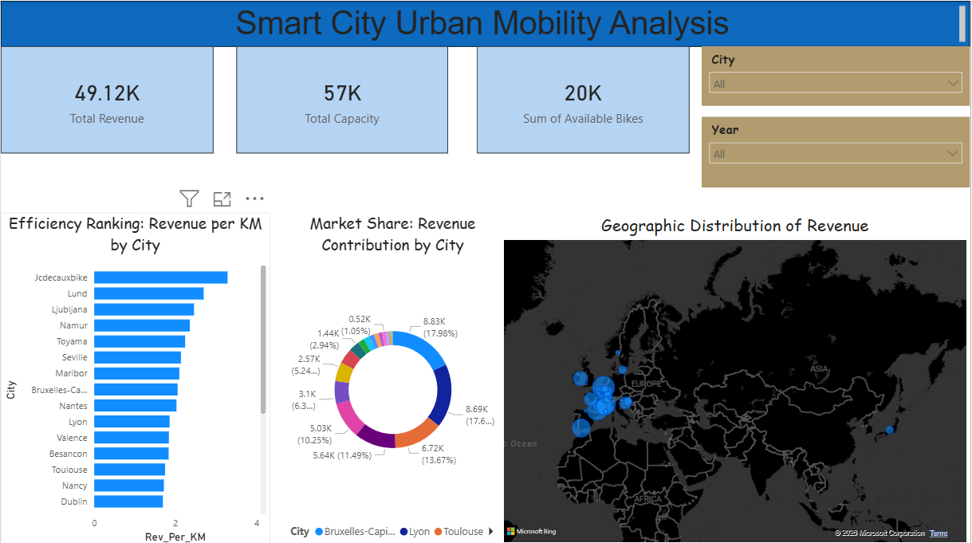
Final Insights for Management
- Top Performer: Based on the Rev_Per_KM chart, specific cities (e.g., Jcdecauxbike) show higher efficiency than others.
- Urban Growth: The relationship between Capacity and Revenue indicates that expanding bike stands in high-demand zones will directly scale profitability.
- Operational Warning: Low-revenue cities with high capacity have been identified as "underperformers" for further strategic review.

Prepared by: Ugeshprasanna
Date: April 2026

